Garden Background scene for game Mood Board

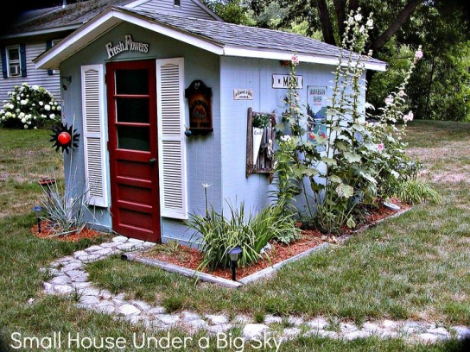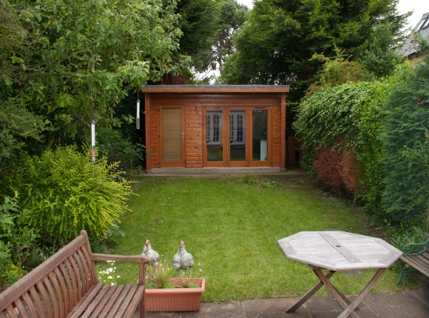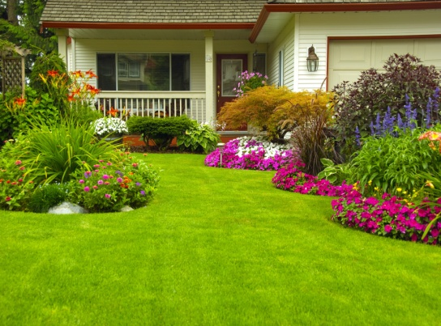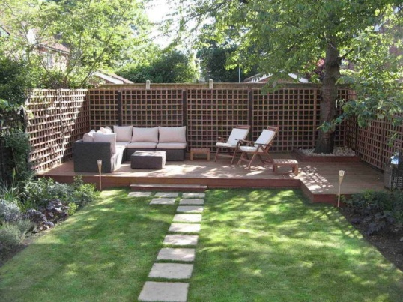

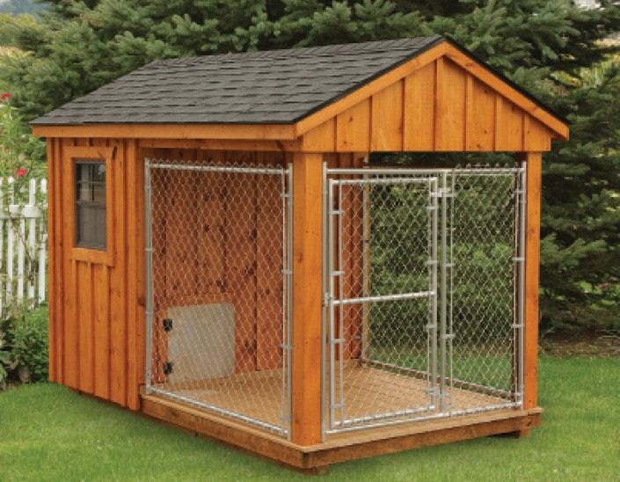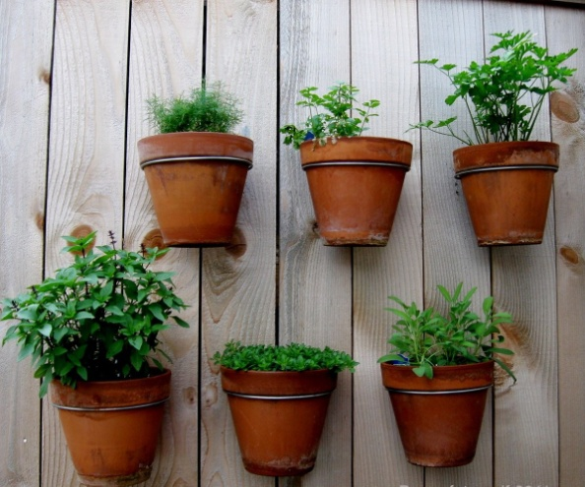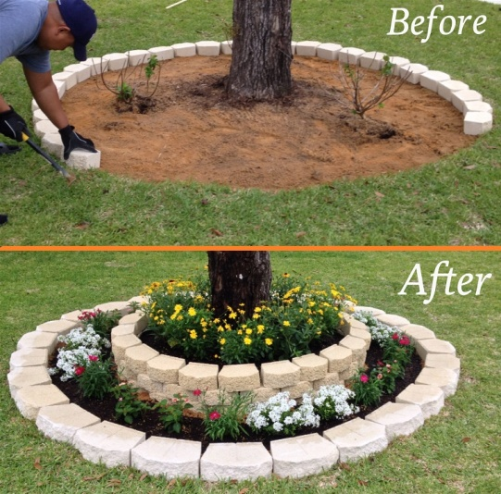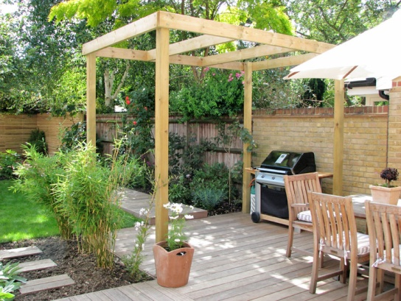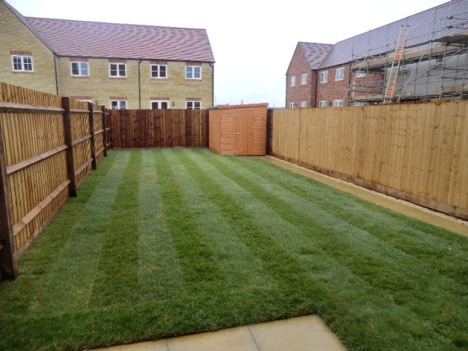

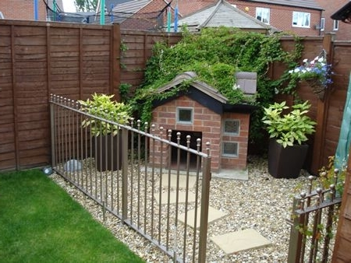

References

Clark, H. (2017). *The Platia Garden Fountain*. [online] Pinterest. Available at: <https://www.pinterest.co.uk/pin/81979655690391732/> [Accessed 22 Nov. 2017].

Cox, L. (2014). *From the drawing board: A garden for relaxation 2 years on | Lisa Cox Garden Designs Blog*. [online] Blog.lisacoxdesigns.co.uk. Available at: <https://blog.lisacoxdesigns.co.uk/from-the-drawing-board/from-the-drawing-board-a-garden-for-relaxation-2-years-on/> [Accessed 22 Nov. 2017].

Ford, S. (2017). *Gardeners Apprentice Garden Tool Set*. [online] spottygreenfrog.co.uk. Available at: <https://www.spottygreenfrog.co.uk/Gardeners-Apprentice-Garden-Tool-Set/p-204-105-361-393/> [Accessed 22 Nov. 2017].

Iconhomedesign.com. (2016). *Best Clay Pot Crafts for the Garden*. [online] Available at: <http://www.iconhomedesign.com/clay-pot-crafts-ideas-and-inspirations.html/best-clay-pot-crafts-for-the-garden> [Accessed 22 Nov. 2017].

Kirkland, M. (2017). *Small Garden Natural Decoration Design Ideas | British Garden ... - Nationals Home Plate*. [online] Nationalshomeplate.com. Available at: <http://nationalshomeplate.com/detail/dbb58c37-small-garden-natural-decoration-design-ideas-british-garden.html> [Accessed 22 Nov. 2017].

Massing, J. (2013). *Extreme [dog]Home Makeover*. [online] Pinterest. Available at: <https://www.pinterest.co.uk/pin/572872015091050026/> [Accessed 22 Nov. 2017].

Maynor, M. (2017). *Beautiful House Gardens Also Flower Garden Trends Pictures Houses Landscaping Plans Home Design With Wondrous Concept ~ Garden Trends*. [online] Garden Trends. Available at: <http://www.artistic-law.com/small-house-gardens-decoration-idea-luxury-fantastical-in-room-design-ideas-acehighwine/beautiful-house-gardens-also-flower-garden-trends-pictures-houses-landscaping-plans-home-design-with-wondrous-concept/> [Accessed 22 Nov. 2017].

Perez, C. (2016). *What To Look For In An Outdoor Dog Kennel For A Schutzhund? – Willamette Valley Schutzhund Club*. [online] Willamettevalleyschutzhundclub.com. Available at: <http://www.willamettevalleyschutzhundclub.com/what-to-look-for-in-an-outdoor-dog-kennel-for-a-schutzhund/> [Accessed 22 Nov. 2017].

Photoaging.net. (2015). *PHOTOAGING.NET - You Can Edit Favorite Photos!*. [online] Available at: <http://www.photoaging.net/?image=http://www.mehmetcetinsozler.com/media/this-is-an-adorable-garden-shed-next-door-to-anns-cottage_l_28e5d37fe6acdc65.jpg&title=This%20Is%20An%20Adorable%20Garden%20Shed%20Next%20Door%20To%20Anns%20Cottage&tag=small%20shed%20cottage%20gardens> [Accessed 22 Nov. 2017].

Zillow, I. (2014). *Great Contemporary Deck with Raised beds by Tony Leocadio*. [online] Zillow. Available at: <https://www.zillow.com/digs/contemporary-decks-6103305178/> [Accessed 22 Nov. 2017].